**TASK 1:**

#include <iostream>

using namespace std;

int main(){

int array[9]={};

for(int i=0;i<10;i++){

cout<<"Enter array value:";

cin>>array[i];

}

for(int i=0;i<10;i++){

cout<<array[i]<<" ";

}

return 0;

}

**OUTPUT:**

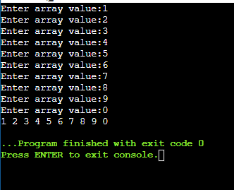

**TASK 2:**

#include <iostream>

using namespace std;

int main(){

int array[5];

int sum=0,product=1,x;

cout<<"Enter 5 integers:"<<endl;

for(int i=0;i<5;i++){

cin>>array[i];

}

for(int i=0;i<5;i++){

x=array[i];

product*=x;

sum+=x;

}

cout<<"Sum of array is:"<<sum<<endl;

cout<<"Product of array is:"<<product<<endl;

return 0;

}

**OUTPUT:**

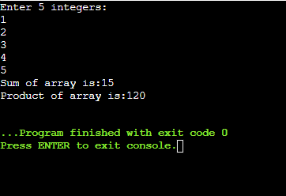

**TASK 3:**

#include <iostream>

using namespace std;

int main(){

int half,size;

cout<<"Enter size:";

cin>>half;

size=(half*2)-1;

char diam[size+1]={};

for(int x=0;x<size;x++){

diam[x]=' ';

}

for(int x;x<half;x++){

diam[half-x]='*';

diam[half+x]='*';

for(int y=0;y<=size;y++){

cout<<diam[y];

}

cout<<endl;}

for(int x=half-1;x>0;x--)

{

diam[half-x]=' ';

diam[half+x]=' ';

for (int y=0;y<=size;y++){

cout<<diam[y];

}

cout<<endl;

}

return 0;

}

**OUTPUT:**

